The Bourdet Family

The Bourdet family with Rene Laurent Bourdet as father, and Lydia Anne Stewart as mother has a rich heritage on both sides of the family.

Rene was born in San Francisco, California in 1920. He was raised in a two-parent home on Bush Street, His father, Cyprien owned a French laundry. His mother, Lucie also worked there. His older brother, Pierre (Pete) worked at a bakery until he enlisted in the Army during World War II. They lived on Bush Street in Sn Francisco (the home is still there).

The family was Catholic, and they worshipped at Église Notre-Dame-des-Victoires, also on Bush Street. During High School, Rene attended High School of Commerce on Van Ness Avenue where he excelled in Basketball. <https://goo.gl/maps/dX28n6cMYHWT8eE68>

Around 1937-38, the family moved to Saratoga, California, which at that time was a famous fruit growing area now known as "Silicon Valley". Rene's father bought a bunch of land with other French Americans, and created Wildwood Park, a resort and amusement park for the small community.

Rene graduated from Los Gatos High School, and shortly after started working as a butcher at Foothill Meat Market in Saratoga. He was drafted in 1942 to serve in the US Navy. He was stationed in the New York Naval yard where he helped translate for the French ships coming in to port. In February of 1943, he joined the crew of the USS Laub, DD 613 A Benson class destroyer where he served as ship's cook.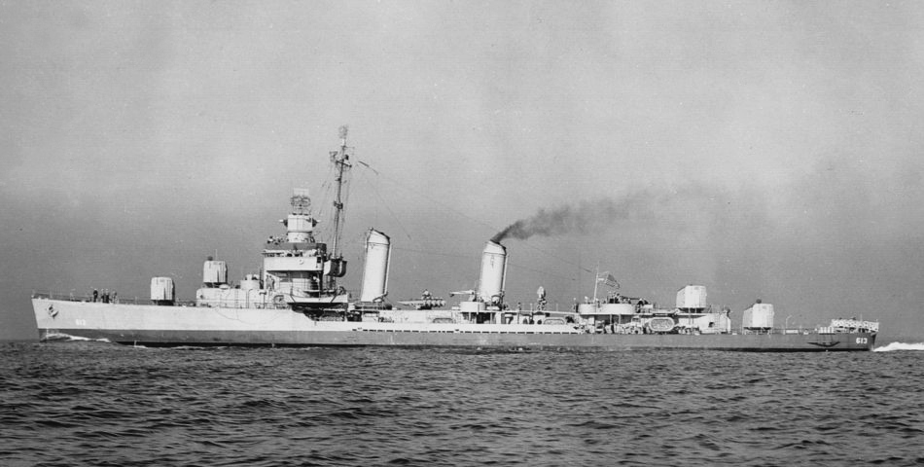

Upon his return, he got married to Connie ? and had two daughters, Linda, born in 1945, and Elaine born in 1947. At some point he and Connie separated, and he met and married Lydia Anne Stewart of Ithaca, New York.

<https://goo.gl/maps/ZUPeBwTCHsZpA8NH9>

<https://goo.gl/maps/VnNHUN1p1cxmcTSQ8>

Lydia was born in St. Petersburg, Florida while her mother was on vacation. Her father, Ralph Walton Stewart, a graduate of Cornell University, was a Landscape Architect. His family roots on his father's side go back many generations in America, but originate in Scotland. On his mother's side, the family originated in Czechoslovakia.

Lydia's mother, Ruth Elizabeth Lowe, was from a very old American family that had its roots in England and Wales. On her side of the family, she was related to Noah and Miriam Webster, the famous wordsmiths. She was also related to the English explorer and privateer Sir Francis Drake.

Her family lived in Detroit Michigan in 1930. She would visit her grandfather, F.C. Stewart in Geneva, New York in the summers. She told of spending the summer in a big "summer" house on a lake with cousins and aunts, uncles and others. She related a time when her grandfather, a botanist, showed her where to find phosphorescent fungi which she used to create a skull and crossbones on the pillows of guests to the family enclave to scare them.

In 1940 she and her sister Janet were living with their maternal grandparents in Ithaca New York. Later, she would study nursing at Syracuse University before moving to California.

By that time, her parents had divorced, and she moved to California, whence her father had moved. He had an apartment on Geary Street in San Francisco. She moved in with a woman named Katherine Delaney after Katherine's husband Jack had passed. Katherine had an appliance repair business in San Jose, CA. Lydia worked for the telephone company as an operator.

Sometime around 1955, Rene and Lydia met and in 1956 they married.

Rene worked as a butcher at Campbell's Market in Saratoga.

Lucie Marie Bourdet was born on October 18, 1956. Lucie still lives in our parents home with her husband Everet Killian, and her two cats Camo and

Michael Rene Bourdet was born on January 18, 1959

Katherine Anne Bourdet was born June 6, 1963.

John Paul Bourdet was born February 25, 1966.